Patrick Henry Chapter #11
The Patrick Henry Chapter #11 of the Texas Society of the Sons of the American Revolution was chartered on 16 May 1938 in Austin, Travis County, Texas as part of the National Society of the Sons of the American Revolution (SAR). Its mission aligns with the broader goals of the SAR: to foster patriotism, preserve American history, and honor the principles of liberty, the Declaration of Independence, the Constitution, and the Bill of Rights. The chapter encourages historical research, preservation of records, and celebration of Revolutionary War anniversaries.
The Patrick Henry Chapter was originally named the Austin Chapter but after the first year was renamed for the Revolutionary War Patriot famous for the words “As for me, give me liberty or give me death.” Founding member, Dr. Henry Winston Harper (b. 1859), Dean of the Graduate School at the University of Texas, was a great-great grandson of Virginia Patriot and Governor Patrick Henry, and the Chapter was named in honor of Dear Harper's illustrious ancestor. (Source: Henry Maxson Flagg)
The chapter has included prominent figures such as President George H. W. Bush, President George W. Bush, and five former Texas Governors along with Governor Greg Abbott who was sworn into the Chapter at the dedication of the SAR Cenotaph at the Texas State Cemetery on 18 Mar 2026. Despite these high-profile members, most participants descend from hardworking Revolutionary War patriots, often farmers and soldiers, reflecting the chapter’s commitment to honoring all ancestors who contributed to American independence.
The Patrick Henry Chapter engages in a variety of activities to promote patriotism and historical awareness. These include:
- Supporting Color Guard activities including multiple parades in Wimberly, Allendale, Round Rock, Lakeway, etc. and special events to include Memorial Day, Flag Retirement Ceremonies, Constitution and George Washington Luncheon, Dell Diamond, and Camp Mabry 250th with flag presentations, drum | bugle | fife, and musket salutes at many of the events.
- Supporting Veterans with flag placement and recovery ceremonies for Memorial Day and Veterans Day and supporting Wreaths Across America | DAR Teams with placement and recovery of 3,300+ wreaths in celebration of Christmas.
- Supporting the military community with award ceremonies for area ROTC and JROTC Units. Since 2015, we have supported a sizable group of University of Texas ROTC and High School JROTC Units.
- Traveling on and Guardian Support of Honor Flight Austin with multiple Compatriots having taken “The Trip of a Lifetime”:
  - George Bright (Flight #99)
  - Jesse O. Villarreal (Flight #103)
  - R. D. Brown (Flight #104).
  - Multiple Compatriots have supported as Guardians with Past President Jim Clements with multiple flights and President Joseph Howell Burton will celebrate his 60th supported flight (including 2 to Washington DC) with Flight #105 on 28 Aug 2026.
- Preserving records, documents, and relics related to Revolutionary War patriots.
- Celebrating anniversaries of key events from the Revolutionary period.
- Fostering fellowship among descendants of Revolutionary War patriots and inspiring the broader community to respect the founding principles of the United States.
- Supporting educational initiatives and public service programs in line with SAR objectives.
Historical records of the chapter, including correspondence, minutes, applications, and publications from 1937 to 1945, are preserved and available for research txarchives.org. These documents provide insight into the chapter’s early activities, membership, and contributions to the Texas SAR and national SAR missions.
Patriot Award Recipients
Congratulations to our Immediate Past President, Shiidon Hawley for being inducted at our hosted 2026 SAR Texas State Convention joining 11 other Chapter Compatriots who have received the State’s highest honor.
The Patriot Medal is awarded only by a state society. It is the highest award given for service at the state or chapter level. This medal is presented only to individuals and may be received ONLY once. It represents long, faithful and outstanding service at the state and / or chapter level.
The medal is sterling silver and bears the portrait of Compatriot General of the Army Douglas MacArthur on the obverse within the inscription, "The National Society of the Sons of the American Revolution." The reverse is inscribed "Awarded to for Patriotic Service by the Society SAR, 20". The medal is suspended from a chest ribbon of royal blue color. The design for the medal was selected by Compatriot MacArthur. He received the first medal, presented posthumously at his tomb in Norfolk, Virginia, on October 19, 1964, where it is on permanent display.
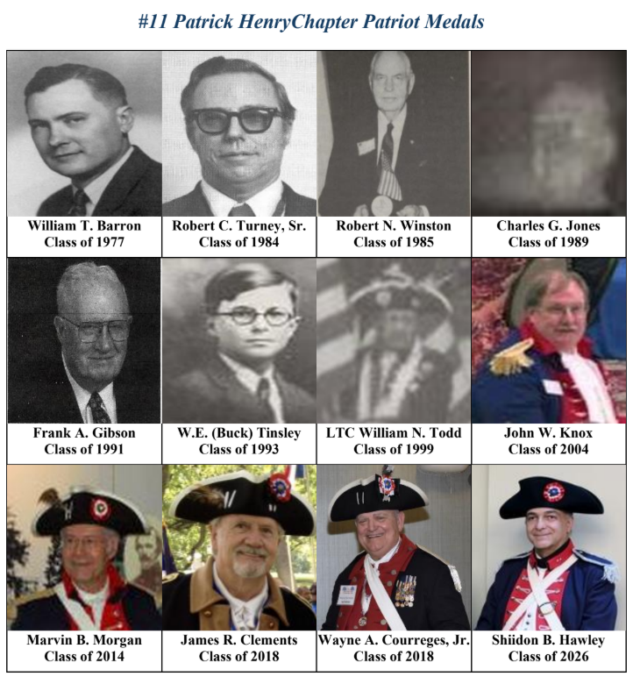

Patrick Henry Chapter – In Memoriam
Since the dawn of the new millennium, our Patrick Henry Chapter has bid farewell to these Compatriots whose dedication, patriotism, and fellowship enriched our society.
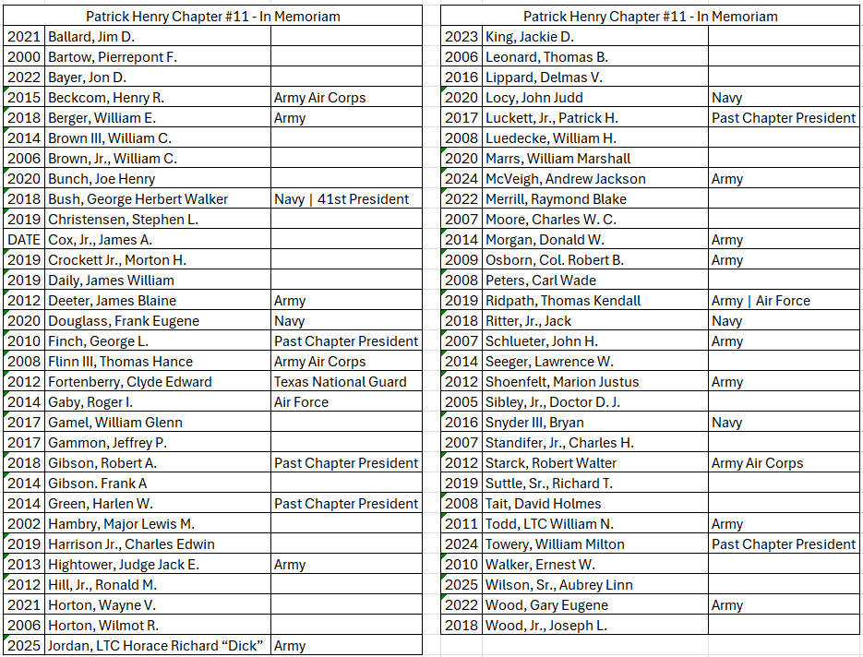
2021 - 2024 New Compatriots
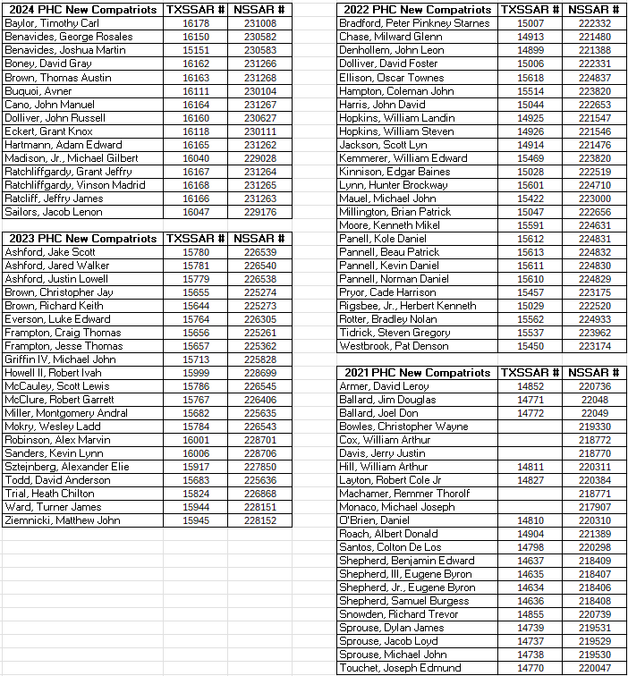

2016 - 2020 New Compatriots
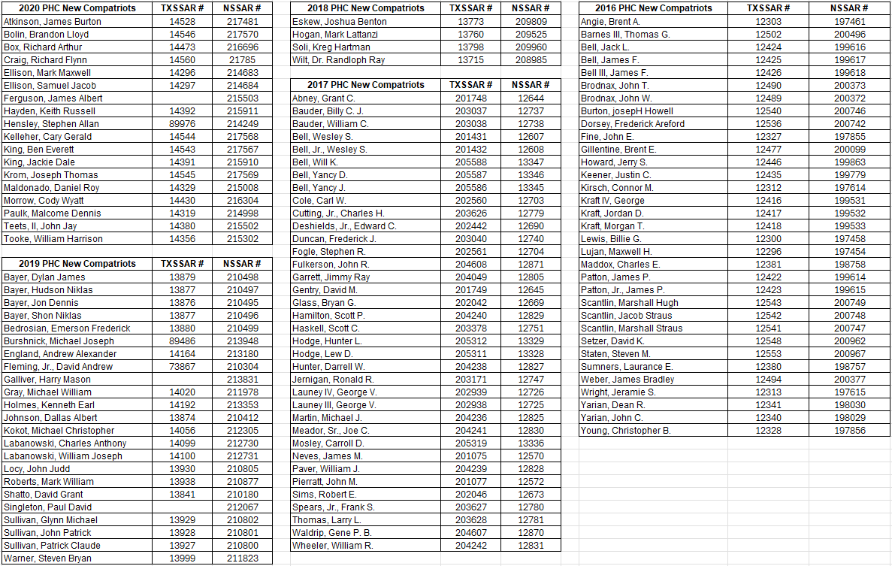
2000 – 2026 Awards Received by the Patrick Henry Chapter from SAR National
- Partners in Patriotism
  - 2016
2000 – 2026 Awards Received by the Patrick Henry Chapter from SAR Texas
- The Alexander Hamilton Pin: Awarded to individuals who give $500.00 to the Patriots Fund.
  - John Knox

- Col. Joe M. Hill Patriot Fund Awards: Awarded annually to each Chapter that has total contributions that exceed the total of the previous year.
  - 2025
  - 2023
  - 2022
  - 2018
  - 2017
  - 2016
  - 2012
  - 2010
- Col. Joe M. Hill Jr. Membership Award: Is presented in honor of our past President Col. Joe. M. Mill Jr. and is given to each chapter that achieves the goal of 100% membership renewal in the past year.
  - 2022
  - 2021
  - 2019
  - 2017
- The Ross Shipman Awards: Selected by the Newsletter Committee. Best Newsletters published during the past year.
  - 2023 [The Patrick Henry Crier; James Clements, Editor – 3rd Place (Large Chapters)]
- The Adrian Drouilhet Award: Named for Sect. Treasurer Emeritus Adrian Drouilhet, and awarded to the Chapter with the most new members under 50 years of age.
  - 2024 (Honorable Mention)
  - 2023 (Honorable Mention)
  - 2021 (Honorable Mention)
  - 2017 (16)
  - 2013 (12)
  - 2011 (12)
  - 2010 (12)
- Texas SAR Flag Presentation Awards: Given to Chapters having recognized an Individual, Company, or Organization for the proper display, maintenance, and care for flying the Flag of the United States during the past year.
  - 2022
  - 2021
  - 2020
  - 2019
  - 2017
  - 2014
  - 2013
  - 2011
  - 2010
- Robert Ritchie Oration Awards for Joseph Rumbaugh Contest: This Contest is open to students in the Sophomore, Junior, and Senior Classes in all public, parochial, and private schools. The Oration is presented without script or props. The winner proceeds to the National SAR Contest.
  - 2011 [Gibson Duncan Hatch – 4th Place]
  - 2010 [Gibson Hatch – 3rd Place]
- The Hartsell O. Stephens Award: Given in honor of Hartsell O. Stephens and awarded to the individual who sponsors the most new compatriots during the past Texas SAR year.
  - 2018 - John E. Fine (35 Apps)
  - 2017 - Jeffrey P. Gammon (29 Apps)
  - 2016 - Jeffrey P. Gammon (29 Apps)
- The E. A. Limmer Award: Created by the Heart Of Texas Chapter and is given to the Chapter having the highest percentage of approved Supplemental applications approved during the past year.
  - 2012 (5 Apps – 7.61%)
- Robert Ritchie Oration Awards for Joseph Rumbaugh Contest: This Contest is open to students in the Sophomore, Junior, and Senior Classes in all public, parochial, and private schools. The Oration is presented without script or props. The winner proceeds to the National SAR Contest.
  - 2025 – Harper Quale (3rd Place)
- The James M. Looney Elementary School Poster Contest Award: This contest was developed to help stimulate interest in American History in support of the Texas School Fifth (5th) Grade Curriculum. The Posters are judged on artistic merit, creativity used to express the annual theme, originality of presentation, and show evidence of research done by the student.
  - 2021 - Norah Clayton (5th Place)
  - 2020 - Norah Clayton (5th Place)
- The John K. Harrell CAR Activities Award: This award recognizes Compatriot John Harrell’s dedication and support of the national, state, and local programs, activities, and recognition of the strong relationship between the two societies of the Sons of the American Revolution and the Children of the American Revolution. (Compatriot Harrell believed that building and supporting CAR Societies at all levels would strengthen strong relationships for the common good of NSSAR and NSCAR and would enhance the promise of new members to SAR and DAR. This award is presented to any chapter who participates in 8 of the 10 elements outlined by the NSSAR CAR Committee.)
  - 2019

2000 – 2024 Chapter Awards
Medal/Award | Last Name | First Name
Texas SAR Bernardo de Gálvez Bronze Color Guard Medal | Baker | O'Rion
Texas SAR Bernardo de Gálvez Bronze Color Guard Medal | Baker | Quinn
Bronze Roger Sherman Medal | Barker, IV | Emzy
Texas SAR Bernardo de Gálvez Bronze Color Guard Medal | Barker, IV | Emzy
Martha Washington Medal | Bird | Betty Sue
Bronze Good Citizenship Medal | Burton | Joseph Howell
Bronze Texas Service Medal | Burton | Joseph Howell
NSSAR Military Service Medal | Burton | Joseph Howell
Bronze Henry Knox Certificate and Medal | Chapel | Gary
Bronze Meritorious Service Medal with Oak Leaf Cluster | Chapel | Gary
Bronze Roger Sherman Medal | Chapel | Gary
Bronze Texas Service Medal | Chapel | Gary
Silver Texas Service Medal | Chapel | Gary
Texas SAR Bernardo de Gálvez Bronze Color Guard Medal | Chapel | Gary
War Service Medal with Theater Bar: Vietnam | Chapel | Gary
Bronze Good Citizenship Medal | Clements | James
Bronze Liberty Friendship Medal | Clements | James
Bronze Roger Sherman Medal | Clements | James
Bronze Service to Veterans Medal with Oak Leaf Cluster | Clements | James
Bronze Texas Service Medal | Clements | James
Chapter Distinguished Service Medal | Clements | James
Past President Medal | Clements | James
SAR 125th Anniversary Medal | Clements | James
Silver Meritorious Service Medal | Clements | James
Silver Roger Sherman Medal | Clements | James
Silver Texas Service Medal | Clements | James
Silver Good Citizenship Medal | Clements | James
Silver Patriot Medal | Clements | James
Texas SAR Bernardo de Gálvez Bronze Color Guard Medal | Clements | James
Texas SAR Bernardo de Gálvez Silver Color Guard Medal | Clements | James
War Service Medal with Theater Bar: Vietnam | Clements | James
Bronze Meritorious Service Medal | Cook | Sam
Bronze Roger Sherman Medal | Cook | Sam
Bronze Texas Service Medal | Cook | Sam
Bronze Texas Service Medal | Cotton | Casey
Texas SAR Bernardo de Gálvez Bronze Color Guard Medal | Cotton | Casey
Bronze Good Citizenship Medal | Courreges, Jr. | Wayne
Bronze Roger Sherman Medal | Courreges, Jr. | Wayne
Bronze Service to Veterans Medal | Courreges, Jr. | Wayne
Bronze Sestercentennial Recognition Award | Courreges, Jr. | Wayne
Bronze Texas Service Medal | Courreges, Jr. | Wayne
Chapter Distinguished Service Medal | Courreges, Jr. | Wayne
Past President Medal | Courreges, Jr. | Wayne
Robert E. Burt Scouting Medal | Courreges, Jr. | Wayne
SAR 125th Anniversary Medal | Courreges, Jr. | Wayne
Silver Patriot Medal | Courreges, Jr. | Wayne
Silver Roger Sherman Medal | Courreges, Jr. | Wayne
Silver Texas Service Medal | Courreges, Jr. | Wayne
Texas SAR Bernardo de Gálvez Bronze Color Guard Medal | Courreges, Jr. | Wayne
Texas SAR Bernardo de Gálvez Bronze Color Guard Medal | Courreges, Jr. | Wayne
War Service Medal with Theater Bar: Vietnam | Courreges, Jr. | Wayne
Bronze Meritorious Service Medal | Cox | William
Bronze Texas Service Medal | Cox | William
Bronze Texas Service Medal | de los Santos | Colton
Bronze Meritorious Service Medal | Deshields | Ed
Bronze Texas Service Medal | Deshields | Ed
NSSAR Military Service Medal | Deshields | Ed
Bronze Texas Service Medal | Duncan | Fred
SAR 125th Anniversary Medal | Duncan | Fred
Bronze SAR Medal of Appreciation | Duncan | Judy
Bronze Texas Service Medal | Ellison | Mark
Bronze Good Citizenship Medal | Eskelund | Mai Lee
Bronze Henry Knox Certificate and Medal | Fine | John
Bronze Liberty Friendship Medal with Silver Oak Leaf Cluster | Fine | John
Bronze Meritorious Service Medal | Fine | John
Bronze Roger Sherman Medal | Fine | John
Bronze Texas Service Medal | Fine | John
Bronze Texas Service Medal | Fitzgerald | Tom
Bronze Texas Service Medal | Fogle | Steven
NSSAR Military Service Medal | Fogle | Steven
Bronze Good Citizenship Medal | Gammon | Jeffrey
Bronze Meritorious Service Medal | Gammon | Jeffrey
Bronze Service to Veterans Medal with Oak Leaf Cluster | Gammon | Jeffrey
NSSAR Military Service Medal | Graham, Jr. | William Eugene
Bronze Good Citizenship Medal | Hawley | Shiidon
Bronze Meritorious Service Medal | Hawley | Shiidon
Bronze Roger Sherman Medal | Hawley | Shiidon
Bronze Texas Service Medal | Hawley | Shiidon
Texas SAR Bernardo de Gálvez Bronze Color Guard Medal | Hawley | Shiidon
Texas SAR Bernardo de Gálvez Silver Color Guard Medal | Hawley | Shiidon
Bronze Roger Sherman Medal | Hicks | Ben
Bronze Texas Service Medal | Hicks | Ben
Bronze Good Citizenship Medal | Hites, Jr. | Robert
Bronze Meritorious Service Medal | Hites, Jr. | Robert
Bronze Service to Veterans Medal with Oak Leaf Cluster | Hites, Jr. | Robert
Bronze Texas Service Medal | Hites, Jr. | Robert
Chapter Distinguished Service Medal | Hites, Jr. | Robert
NSSAR Military Service Medal | Hites, Jr. | Robert
President’s Distinguished Service Award | Hites, Jr. | Robert
Texas SAR Bernardo de Gálvez Bronze Color Guard Medal | Hites, Jr. | Robert
Texas SAR Bernardo de Gálvez Bronze Color Guard Medal | Hites, Jr. | Robert
War Service Medal with Theater Bar: Afghanistan-2006 | Hites, Jr. | Robert
War Service Medal with Theater Bar: Global War on Terrorism-2010 | Hites, Jr. | Robert
War Service Medal with Theater Bar: Iraq-2012 | Hites, Jr. | Robert
Bronze Meritorious Service Medal | Horton | Jim
Bronze Roger Sherman Medal | Horton | Jim
Bronze Texas Service Medal | Horton | Jim
Robert E. Burt Scouting Medal | Horton | Jim
Silver Meritorious Service Medal | Horton | Jim
Silver Texas Service Medal | Horton | Jim
Texas SAR Bernardo de Gálvez Bronze Color Guard Medal | Jordan | Robert
Bronze Henry Knox Certificate and Medal | Knox | John
Bronze Roger Sherman Medal | Knox | John
Chapter Distinguished Service Medal | Knox | John
Bronze Good Citizenship Medal | Lattig | Kent
Bronze Texas Service Medal | Machamer | Remmer
War Service Medal with Theater Bar: Southwest Asia | Mayfield | Christopher Dale
War Service Medal with Theater Bar: Vietnam | McVeigh, III | Andrew
Bronze Meritorious Service Medal | Miller | Max
Bronze Roger Sherman Medal | Miller | Max
Bronze Texas Service Medal | Miller | Max
Silver Texas Service Medal | Miller | Max
War Service Medal with Theater Bar: Vietnam | Miller | Max
Bronze Roger Sherman Medal | Morgan | Marvin
Texas SAR Bernardo de Gálvez Bronze Color Guard Medal | Morrow | Emma
Bronze Texas Service Medal | Moulton | Ron
Texas SAR Bernardo de Gálvez Bronze Color Guard Medal | Moulton | Ron
NSSAR War Service Medal | Moyer | Jeffrey John
Bronze Texas Service Medal | Mullins | Phil
Bronze Roger Sherman Medal | Navarro | Kristofer
Bronze Texas Service Medal | Navarro | Kristofer
Bronze Roger Sherman Medal | Nelson | Christian
Texas SAR Bernardo de Gálvez Bronze Color Guard Medal | Nelson | Christian
Bronze Good Citizenship Medal | Nelson | James
Bronze Meritorious Service Medal | Nelson | James
Bronze Roger Sherman Medal | Nelson | James
Texas SAR Bernardo de Gálvez Bronze Color Guard Medal | Nelson | James
NSSAR Military Service Medal | Osborn | Richard
War Service Medal with Theater Bar: Korea | Parsons | Mark William
Bronze Roger Sherman Medal | Ridpath | Tom
Bronze Texas Service Medal | Ridpath | Tom
Bronze SAR Medal of Appreciation | Shoenfelt, II | Henry
NSSAR Military Service Medal | Shoenfelt, II | Henry
Texas SAR Bernardo de Gálvez Bronze Color Guard Medal | Shoenfelt, II | Henry
Texas SAR Bernardo de Gálvez Bronze Color Guard Medal | Smith | Alexander
Bronze Meritorious Service Medal | Smith | David S.
Texas SAR Bernardo de Gálvez Bronze Color Guard Medal | Smith | Nathan
Membership | Swearingen | Yance Gordon
Martha Washington Medal | Thomas | Kathi
Bronze SAR Medal of Appreciation | Tooke | Gretchen
Martha Washington Medal | Tooke | Gretchen
Silver Texas Service Medal | Tooke | Gretchen
Bronze Texas Service Medal | Tooke | Harry
Texas SAR Bernardo de Gálvez Bronze Color Guard Medal | Tooke | Harry
126th National Congress | Tooke | Kenneth
Bronze Roger Sherman Medal | Tooke | Kenneth
Bronze Service to Veterans Medal | Tooke | Kenneth
Bronze Texas Service Medal | Tooke | Kenneth
Chapter Distinguished Service Medal | Tooke | Kenneth
Liberty Medal | Tooke | Kenneth
Past President Medal | Tooke | Kenneth
SAR 125th Anniversary Medal | Tooke | Kenneth
Silver Meritorious Service Medal | Tooke | Kenneth
Silver Roger Sherman Medal | Tooke | Kenneth
Silver Texas Service Medal | Tooke | Kenneth
Texas SAR Bernardo de Gálvez Bronze Color Guard Medal | Tooke | Kenneth
War Service Medal with Theater Bar: Southwest Asia | Tooke | Kenneth
Bronze Meritorious Service Medal | Walcik | Ron
Bronze Roger Sherman Medal | Walcik | Ron
NSSAR Distinguished Service Medal | Walcik | Ron
NSSAR Military Service Medal | Walcik | Ron
NSSAR Patriot Medal | Walcik | Ron
Bronze Texas Service Medal | Warner | Steven
NSSAR Military Service Medal | Weber | James B.
War Service Medal with Theater Bar: Global War on Terrorism | Welling | David
War Service Medal with Theater Bar: Iraq | Welling | David
War Service Medal with Theater Bar: Southwest Asia | Welling | David
Bronze Roger Sherman Medal | White | Gary
War Service Medal with Theater Bar: Vietnam | White | Gary
Bronze Roger Sherman Medal | Wise | Jeffery
Chapter Distinguished Service Medal | Wise | Jeffery
Texas SAR Bernardo de Gálvez Bronze Color Guard Medal | Wise | Jeffery
Texas SAR Bernardo de Gálvez Bronze Color Guard Medal | Wise | Jeffery
NSSAR Military Service Medal | Woodstrom | Harry Roger

Presidential Term Histories
President Emeritus George Finch - 2010
During President Finch’s term our Patrick Henry Chapter proudly hosted the SAR Texas State Convention.

President Emeritus and Chapter Vexillologist John Knox – 1999 - 2000
Back in the late 1990s, the Patrick Henry Chapter had a compatriot named Jack Hightower, a former U.S. Representative. Jack contacted then-Governor George W. Bush and asked whether he would join the Sons of the American Revolution. Governor Bush agreed, and we began completing the necessary paperwork.
During the summer of 1998, we received his approved application. A contingent from the Patrick Henry Chapter and the Texas Society of the Sons of the American Revolution traveled to the Texas State Capitol to induct Governor Bush into the SAR. Unfortunately, Jack was in Washington, D.C. and could not accompany us.
We gathered in the Governor's waiting room and prepared for the induction. When Governor Bush entered, he asked, "What are we here for today?" The TXSSAR president explained that we were there to induct him into the Sons of the American Revolution. It soon became clear that Governor Bush knew little about the organization. We had only five minutes with him, so we administered the oath, took a group photograph, and left the office. We realized afterward that we had made a serious mistake by proceeding without Representative Hightower, who had arranged the Governor's membership.
In 2003, former President George H. W. Bush retired and moved to Houston. I did not want to repeat the mistake we had made when inducting his son. TXSSAR President Nathan White contacted me and said we would be inducting the former president into the SAR. I agreed but insisted that Jack Hightower join us.
Frank Gibson and I contacted Jack and invited him to participate in the induction ceremony. The three of us left Austin and drove to Houston. When we arrived, we were met by the SAR President General from Louisiana, TXSSAR President Nathan White, and several representatives from Houston-area Chapters.
When we entered former President Bush's office, he immediately recognized Jack. It was like old home week. We all shook hands with President Bush while he and Jack reminisced about old times.
We inducted President Bush into the SAR through the same ancestor who had qualified his son. After administering the oath, we asked whether we could take a group photograph with him, and he gladly agreed. Afterward, he asked whether we would also like individual photographs, so each of us had a picture taken with him. President Bush even autographed a book for Nathan White, and I received his autograph as well.
We had expected the visit to last only 15 minutes, but we ended up spending about an hour with him. It was a wonderful and memorable occasion.
When I returned to Austin, we made both former President George H. W. Bush and President George W. Bush Perpetual Compatriots of the Patrick Henry Chapter so we would never have to worry about either being dropped from the membership rolls.

President Emeritus Jim Nelson – 2013 - 2014
Our Patrick Henry Chapter coordinated with the DAR to continue the tradition of hosting the Memorial Day Ceremony at the Texas State Cemetery for both years of my term. Our Chapter also hosted the George Washington’s Birthday Luncheon and joined the Constitution Day Luncheon, with Compatriot John Knox providing his famous Flags Presentation, with the DAR at the Austin Woman’s Club, Chateau Bellevue.
In 2013, we proudly celebrated the 75th anniversary of the Chapter with a celebratory luncheon held at the Hilton Garden Inn with the District 4 Vice President, Ronald J. Walcik and the State Vice President, Robert S. Cohen both in attendance. The State President was ill and could not attend.
We enjoyed attending naturalization ceremonies as members of the Color Guard to welcome new Citizens to our Country.
I attended the SAR Texas State Convention in San Antonio in 2013 hosted by the San Antonio Chapter at the Hilton San Antonio Airport Hotel on 23-25 March.

President Emeritus Wayne Allen Courreges, Jr. – 2015 - 2016
Growth, Leadership, and Patriotic Service
Wayne Allen Courreges, Jr. served as President of the Patrick Henry Chapter, Texas Society, Sons of the American Revolution, during the years of 2015 and 2016. The Chapter’s official roster identifies James R. Clements as President-Elect, James Nelson as Immediate Past President, David S. Smith as Secretary, James Horton as Treasurer, Jeff Gammon as Registrar, Ken Tooke as Historian and Webmaster, Max Miller as Chaplain, Henry Elvin Shoenfelt, II as Children of the American Revolution Liaison, and Jeffrey G. Wise as Color Guard Commander. Together, these officers provided leadership for a particularly active period in the Chapter’s history.
Chapter members and guests gathered monthly at the Texas Land & Cattle Company in Austin. The meetings combined fellowship, a business session, and speakers addressing historical, patriotic, military, and civic subjects. Chapter literature emphasized that meetings were open to the public and welcomed spouses, families, prospective members, and guests. This welcoming atmosphere helped create opportunities for both membership recruitment and the development of future Chapter leaders.
A defining feature of the Courreges administration was the growth and increasing public visibility of the Patrick Henry Chapter Color Guard under the command of Captain Jeffrey G. Wise. The Chapter described its Color Guard as comprising compatriots portraying Continental soldiers, militiamen, and other Revolutionary-era figures for historical, patriotic, and educational purposes. The Chapter also actively encouraged new members to obtain uniforms and participate in public ceremonies.
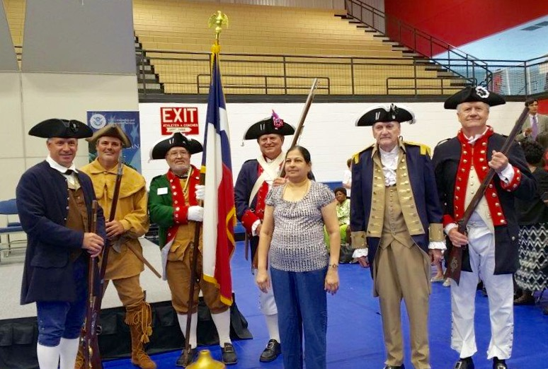
The Color Guard’s participation in naturalization ceremonies was especially meaningful. On June 16, 2015, Patrick Henry Chapter members Tom Northen, Henry Shoenfelt, Jeff Wise, Wayne Courreges, Jim Clements, Jim Nelson, Ron Walcik, Bill Marrs, and Emzy Barker participated in an Austin naturalization ceremony. After presenting the Colors, the uniformed compatriots welcomed and posed for photographs with newly naturalized American citizens and their families. An additional Chapter report records members presenting the Colors at another Austin immigration and naturalization service with support from neighboring Texas SAR chapters.
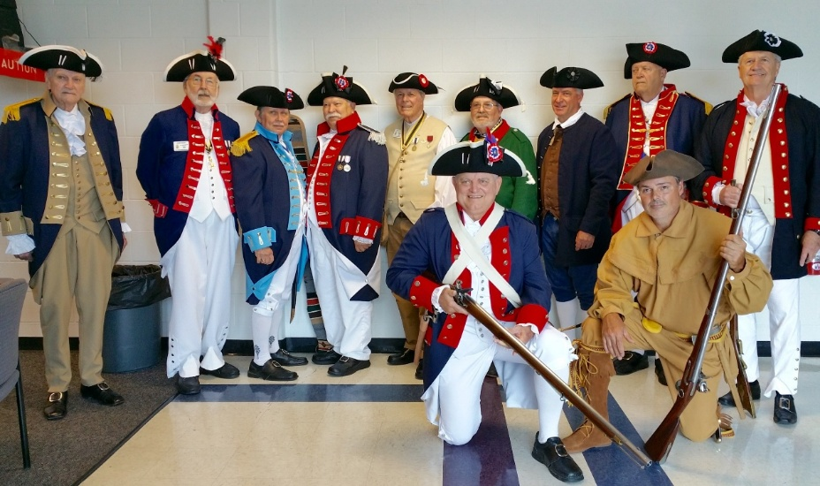
The Chapter’s July Fourth appearance at Dell Diamond in Round Rock became one of its most visible patriotic programs. Before the Round Rock Express baseball game, the Color Guard presented the Colors on the field. President Courreges delivered an Independence Day presentation from an old-fashioned scroll, while John Knox displayed a Betsy Ross flag.
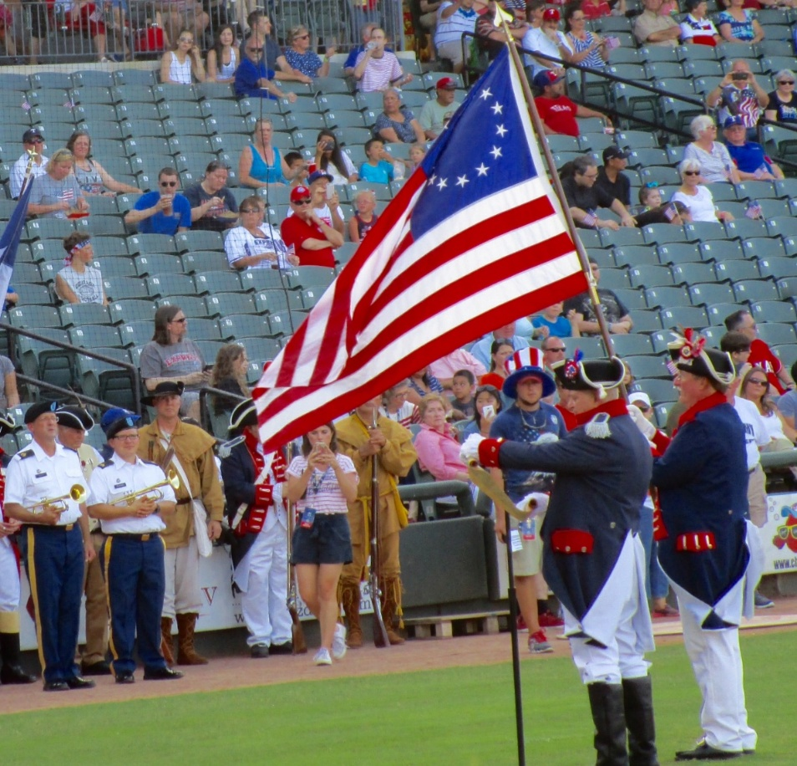
Commander Wise later reported that the presentation produced a powerful response from the crowd and that stadium representatives expressed interest in making the Chapter’s participation an annual event. The Chapter returned to Dell Diamond in 2016, and its published calendar formally listed the July Four presentation of the Colors.
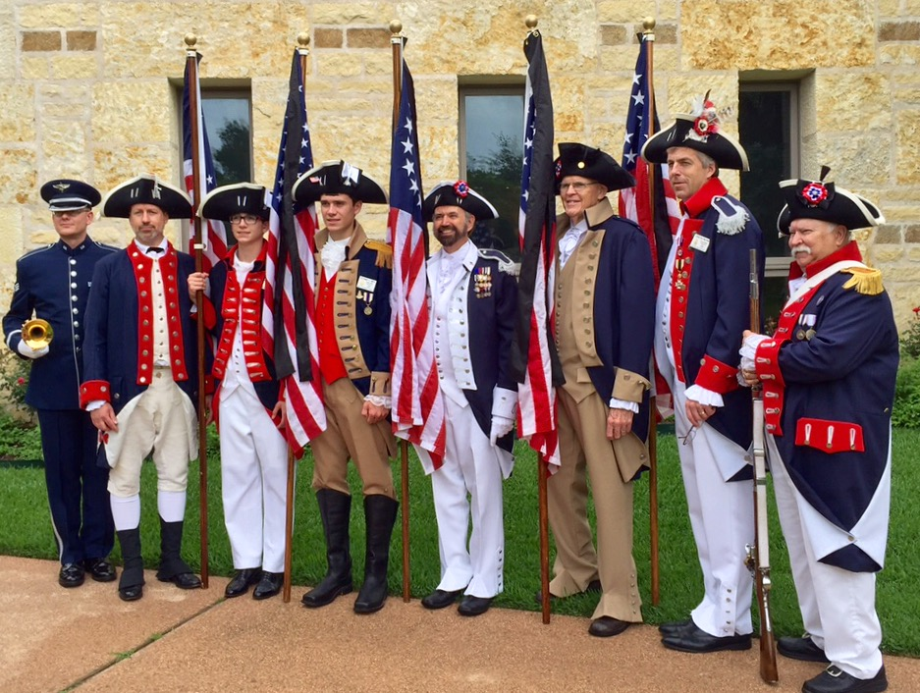
The Chapter also joined the Thankful Hubbard Chapter, Daughters of the American Revolution, in sponsoring the annual Memorial Day service at the Texas State Cemetery. During the 2015 observance, SAR members in Revolutionary War uniforms served as the Color Guard and fired a musket salute in honor of deceased servicemen. The service also recognized the two Revolutionary War veterans buried in the State Cemetery and honored Austin servicemen lost during the Vietnam War. In 2016, the Chapter again participated prominently, with Captain Wise leading the Color Guard and members receiving recognition for their ceremonial service.
George Washington’s Birthday was commemorated through joint SAR–DAR luncheons. February 21, 2015’s program brought together the Patrick Henry and Alexander Hamilton SAR chapters and several area DAR chapters. Captain Wise commanded the combined Color Guard, John Knox presented a program on early American flags, and President Courreges helped coordinate the event with Capital Area Regents Council President Karen Jolly. The 2016 celebration continued this cooperative tradition, with members of the Patrick Henry and Alexander Hamilton chapters posting and retiring the Colors.
Other public appearances included Veterans Day activities, Constitution Day programs, military and veterans’ ceremonies, historical presentations, and the annual FBI gathering in Austin. On September 15, 2016, the Patrick Henry Chapter Color Guard presented the Colors to open an FBI luncheon and was photographed with participating compatriots afterward at the Headliners Club in downtown Austin.

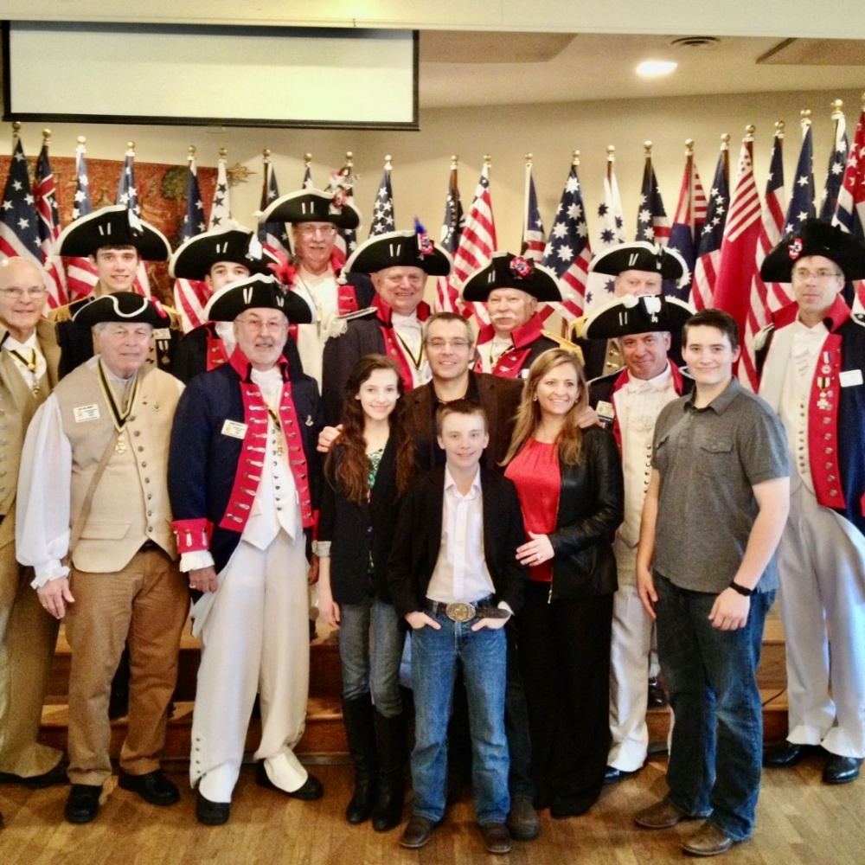
The Courreges administration also strengthened the Chapter’s service to veterans. The Veterans Awards and Service Committee was established at President Courreges’s direction in August 2015 and approved by the Chapter Board of Managers that October. Its purposes included recognizing the military service of Chapter members, organizing assistance for veterans in the community, and documenting volunteer service performed on behalf of veterans. The Chapter also supported Operation Ancestor Search at Fort Hood, where SAR volunteers assisted “Wounded Warriors” in researching their family histories.
Another important accomplishment of the Courreges administration was the Chapter’s successful hosting of the Texas Society SAR Fall Board of Managers Meeting in Austin on October 14–16, 2016. Held at the Holiday Inn Austin Midtown, the event marked the first time in many years that the Patrick Henry Chapter had undertaken responsibility for a statewide Board of Managers meeting. Chapter members staffed registration, supported the Color Guard, organized fundraising activities benefiting the Patriots Fund and Chapter programs, and welcomed Texas SAR officers and compatriots from across the state. The Chapter also helped showcase Austin by arranging a tour of the Bullock Texas State History Museum and a luncheon for the Ladies Auxiliary. Contemporary state and national SAR publications documented the general session and identified the Patrick Henry Chapter’s successfully hosting this annual meeting. This successful meeting demonstrated the Chapter’s organizational ability, teamwork, and renewed prominence within the Texas Society.
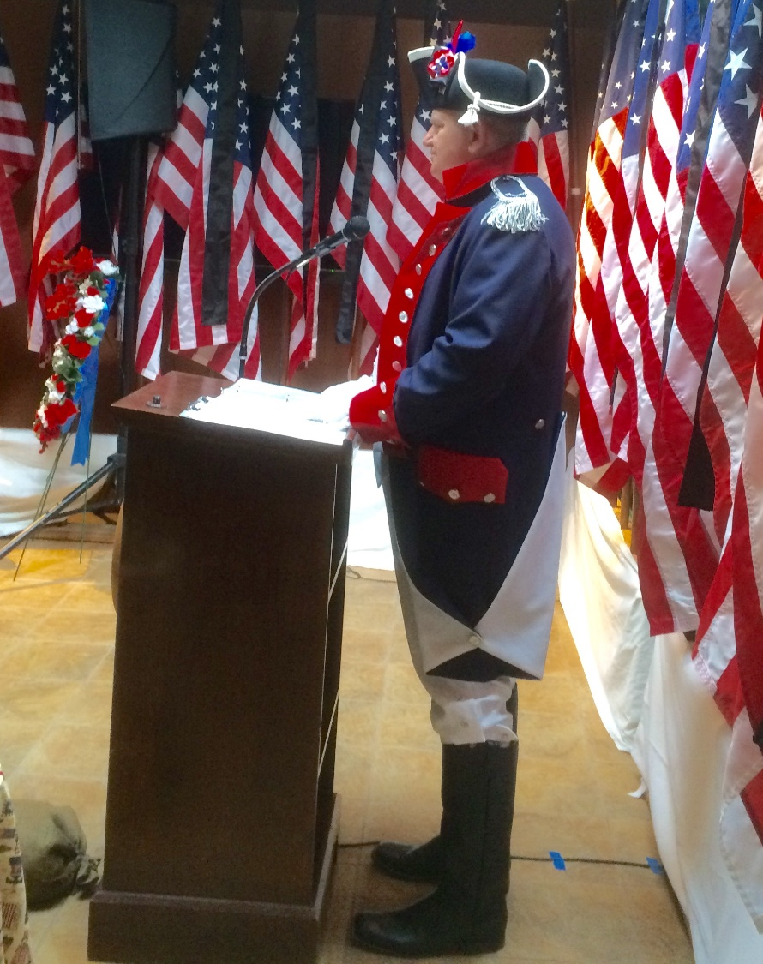
New leadership was visibly emerging. At the March 2016 meeting, the Chapter inducted Ron Moulton, who began leading a new Fife and Drum group, and Conor Kirsch, who was encouraged to participate in Chapter committees. John Knox and Kris Navarro received the Bronze Roger Sherman Medal for service to the Chapter. President-Elect Jim Clements was increasingly prominent in ceremonies and public programs and would succeed Courreges as Chapter President. Clements also presented a ceremonial President’s Sword to the Chapter, establishing the tradition that the name of each successive president would be engraved upon it.
The Chapter’s growth was reflected in state recognition. At the 2016 Texas SAR convention, Registrar Jeffrey P. Gammon received the Hartsell O. Stephens Award after sponsoring twenty-nine new-member applications; more than any other compatriot in the Texas Society that year. The Patrick Henry Chapter was also recognized as a repeat recipient of the Colonel Joe M. Hill Patriots Fund Award. The Chapter subsequently reported that its 2016 record earned recognition for 100-percent membership renewal and the Adrian Drouilhet Award for attracting new members under fifty years of age.
By the conclusion of 2016, the Patrick Henry Chapter strengthened its membership, expanded its Color Guard, developed future officers, increased its cooperation with neighboring SAR and DAR chapters, and established a highly visible presence throughout Central Texas. The Chapter also successfully hosted the Texas Society SAR Fall Board of Managers Meeting—an important statewide responsibility it had not undertaken for many years. Through naturalization ceremonies, patriotic commemorations, veterans’ programs, public presentations, community service, and state-level leadership, the Chapter fulfilled the SAR mission of promoting patriotism, education, and remembrance of the American Revolution.

President Emeritus Jim Clements – 2017 - 2018
Throughout the years of 2017 & 2018 the chapter expanded its chapter membership by participating in several programs including the annual Memorial Day ceremony at the Texas State Cemetery with the placement of 3,200 American Flags on the graves and sponsoring the Memorial Day Service with Military Flag Officers presentations. On veterans Day the chapter again placed 3,200 American Flags on the graves.
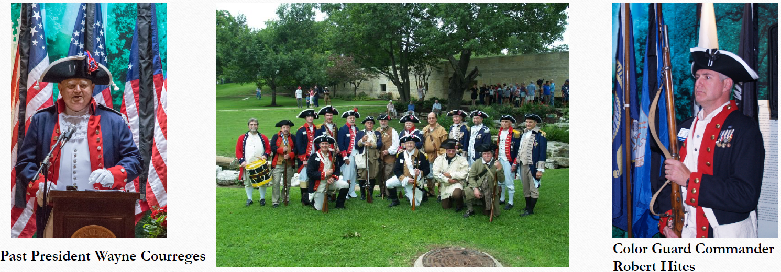
Every year we participated in the Independence Day Parades in Allendale, Wimberley, and San Marcos as well as the Opening Day ceremony at the Dell Diamond. In 2017, we also participated in these activities:
- Laredo, Texas George Washington Day Parade (February)
- Hays County Lincoln | Reagan Dinner (March)
- Texas Mayflower Society (March)
- Texas SAR State Convention in San Antonio, Texas (March)
- Medal of Honor Parade and the Ancestor Grave Marking both in Gainesville, Texas (April)
- Wimberley, Texas Birdies for Business Golf Tournament (April)
- Memorial Day Ceremony at the Texas State Cemetery (May),
- Naturalization Ceremony at the Dell Auditorium in Austin Texas (June)
- Burnett County Fair (June)
- George Washington’s Birthday Proclamation signing ceremony with Texas Senator Donna Campbell and Lt. Governor Dan Patrick at the State Capital (July)
- Flag Folding Ceremony at St. Andrews School in Austin, Texas (September)
- Texas SAR BOM Galveston, Texas (October)
- AMVETS Post #115 Chili Cook-off (PHC 2nd Place!) and Texas SAR Flag Certificate Ceremony in Kyle, Texas (October)
- Veterans Day Parade on Congress Avenue in Austin, Texas (November)
- The French Consul Presenting the Legion of Honor to 6 WWII Veterans Placing the Wreath on the Tomb of the Unknown Soldier (November)
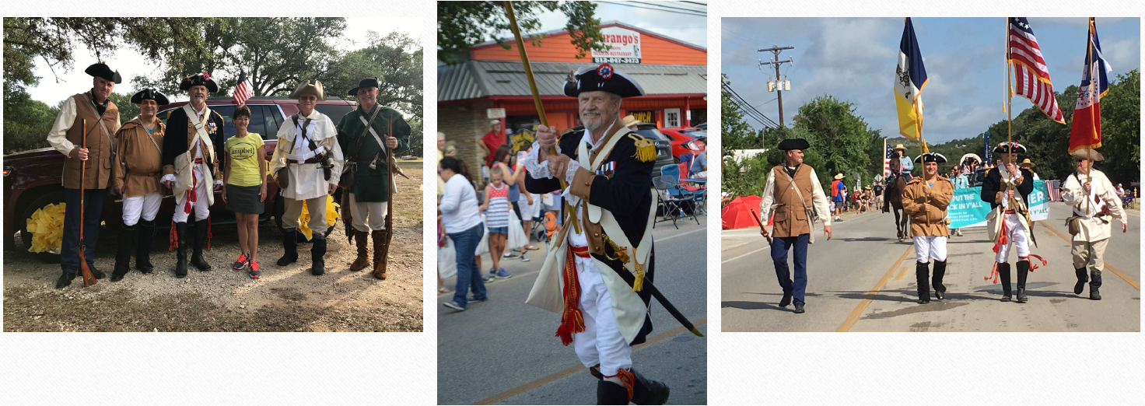
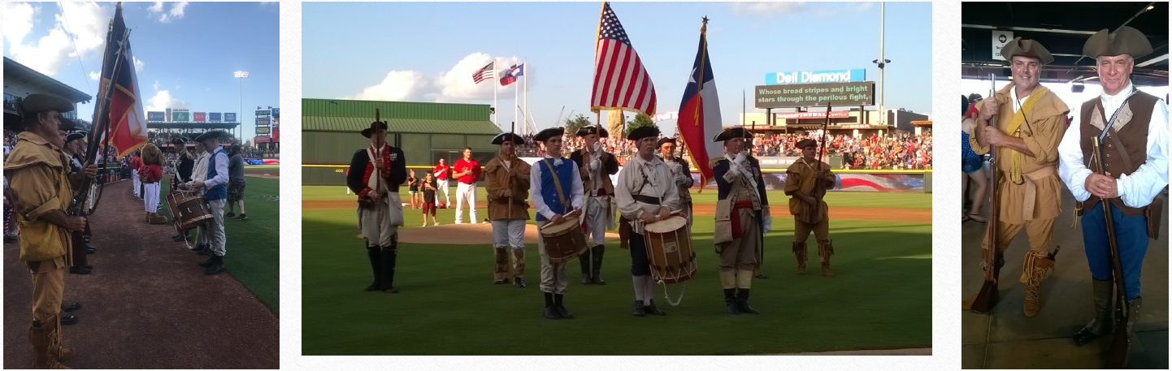
Our Chapter Color Guard also participated in Partnership with the DAR Capital Area Regents in sponsoring the George Washington’s Birthday Luncheon (Admiral Bobby Inman Guest Speaker) at the Austin Woman’s Club, Chateau Bellevue, the original home of TXSAR Founder Ira Evans and the Constitution Day Luncheon annually. In 2017, our Chapter also supported the dedication of the CAR Granite Bench at the serene Texas State Cemetery.
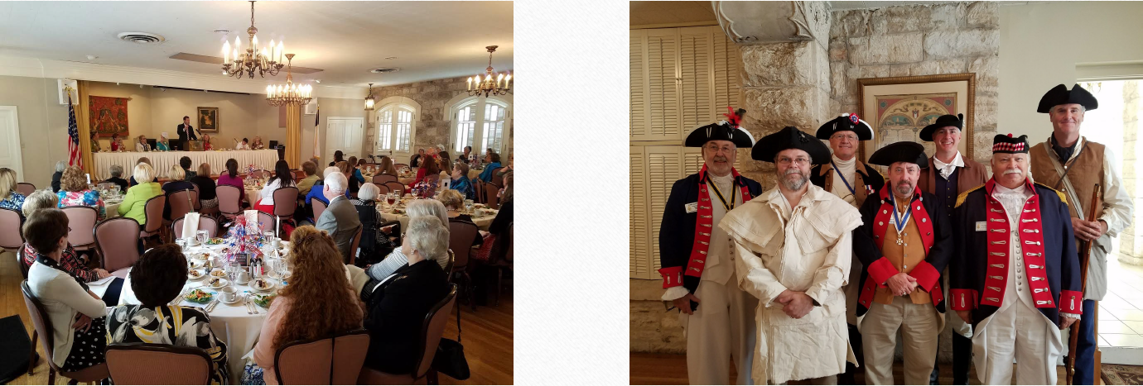
Our Patrick Henry Chapter, the Alexander Hamilton Chapter, and the Ensign Thomas Huling Chapter of the NSDAR continued sponsorship of the successful Operation Ancestor Search (OAS) program at Ft. Hood for Wounded Warriors and added the Veterans Hospital at Temple, Texas in 2017. This program had been in operation since the late Fall of 2015 and had served 156 wounded warriors through my tenure and ended with the Pandemic, pending restart. Our goal was to have four volunteers for each meeting and those of our Chapter who supported during my term included: Jim Nelson, Gary Chaple, Jeff Gammon, Mrs. Eileen Walcik, and Ray DeVries.

President Emeritus Ken Tooke – 2019 - 2020
Leading Through Lockdown:
A Chapter Rooted in History
The Patrick Henry Chapter of the Texas Society, Sons of the American Revolution, chartered in 1938 and based in Austin, has long served as a gathering place for descendants of Revolutionary War patriots. In ordinary times, the chapter meets monthly, maintains an active color guard for parades, wreath-layings, and grave dedications, and works to preserve the records, relics, and landmarks tied to the founding generation. I took office as chapter president in 2019 expecting a fairly traditional term: monthly luncheons, committee reports, a color guard schedule, and the usual work of recruiting and recognizing members. Nothing about the year ahead would be traditional.
The Lockdown Arrives
By March 2020, the COVID-19 pandemic had upended the rhythms that chapter life depends on. In-person meetings, the backbone of any SAR chapter, were no longer possible. Restaurants and meeting halls closed. Color guard appearances at parades, ceremonies, and community events were cancelled almost overnight, taking with them the visible, public-facing work the chapter is known for. For an organization built on face-to-face fellowship, ritual, and remembrance, the sudden absence of gatherings was more than an inconvenience; it threatened the continuity of the chapter's mission during my term.
Adapting the Chapter's Work
Rather than let the chapter go dormant, the leadership team shifted much of its business online, adopting video conferencing for meetings and committee work at a time when many of our members, several of them older veterans and retirees, were themselves learning the technology for the first time. Communication moved to phone calls, email updates, and virtual check-ins to keep members connected and informed as public health guidance changed week to week. Genealogical research, one of the chapter's core functions, continued largely uninterrupted since much of that work was already done independently. Where public ceremonies could not proceed as planned, we looked for smaller, safer ways to honor commemorative dates and continue the chapter's presence in the community without gathering in numbers.
Reflections on the Term
Serving as president during this period was a study in steady leadership under uncertainty. The job was less about ceremony and ritual, and more about keeping an organization intact when the tools it normally relies on were taken away. It meant checking in on members who were isolated, making decisions with incomplete information about a fast-moving public health crisis, and accepting that a term marked by tradition-bound office would instead be remembered for improvisation. What did not change was the purpose behind the chapter: honoring the patriots of the Revolution and the ideals of liberty and self-government they fought for. If anything, a year defined by disruption made that purpose feel more worth preserving, not less.
Looking Back
The 2019–2020 term will always stand apart in the chapter's history, not for what was accomplished in the usual sense, but for what was preserved. The chapter emerged from lockdown intact, its membership connected, its records in order, and its mission unchanged, ready to resume the parades, ceremonies, and meetings that define its public life once it was safe to do so.

President Emeritus Jim Horton – 2021 – 2022
My term started with some challenges with the leadership and I assumed the role of President and was proud to be able to bring this strong group of officers together with willing mentors to support our 2 years successfully.
- President: Jim Horton (mentor Ken Tooke)
- Vice President: Shiidon Hawley (mentor Jim Clements)
- Secretary: Ben Hicks (mentor Ed Deshields)
- Historian: Joseph Howell Burton
- Treasurer: Fred Duncan (mentor Jim Horton)
- Genealogist & Registrar: John Fine & Tom Fitzgerald
- Chaplain: Max Miller
- Webmaster: Sam Cook
- Color Guard Commander: Shiidon Hawley
- New Member Coordinator: Wayne Courreges

Our Patrick Henry Chapter coordinated with the DAR to continue the tradition of hosting the Memorial Day Ceremony at the Texas State Cemetery for both years of my term and I enlisted my unsuspecting Historian, Joseph Howell Burton to emcee the year that I did not lead the ceremony. Our Chapter also hosted the George Washington’s Birthday Luncheon and supported the Constitution Luncheon with the DAR at the Austin Woman’s Club, Chateau Bellevue.
For both Memorial Day and Veterans Day our Chapter coordinated with multiple DAR Chapters and the Young Men’s Service League (YMSL) to place 3,000+ flags on all of the grave markers. This effort was led by our Flag Commander, Kent Lattig and a group of our Compatriot Volunteers. Our Chapter, led by one of our youngest Compatriots, Remmer Machamer (inducted on Memorial Day 2021), who spearheaded bringing Wreaths Across America to our serene Texas State Cemetery, coordinated with our DAR Teammates and 100s of citizens to place 3,000+ wreaths on all of the grave markers in December of both years of my term.
Our Chapter supported the Jacobs Well DAR Chapter’s 30th Anniversary Luncheon with a Posting of the Colors. The Compatriots involved were President Jim Horton, Past Presidents John Knox, Wayne Courreges and Jim Clements, and Fred Duncan along with Stuart Hoyt from our William Hightower Chapter.
On 20 May 2021, Past Presidents Wayne Courreges and Jim Clements, along with Stuart Hoyt were joined by our Chapter Vexillologist (expert on Flags), John Knox to bring the American Revolution to five of Ms. Kristin Wright’s classes at her Rooster Springs Elementary School in Dripping Springs, Texas. She has a deep love for history and is dedicated to her profession as a teacher and goes above and beyond to make the subject come alive to her students. We agreed on a time and were able to film John Knox’s famous flag presentation for her students. For her effort to make all this possible, we presented Ms. Wright with a framed citation of a Silver Martha Washington Medal.
In a similar vein, on Friday, 07 January 2022, Past President Jim Clements and Stuart Hoyt shared "A view of the American Revolution" with six 5th grade classes at the Meridian World Elementary School in Round Rock, Texas. In addition, our Chapter presented a Flag Certificate to the school and a Certificate of Appreciation to each of the following teachers: Kelli Doersam, Ashley Gutierrez, Jenny Longoria, Leslie Robledo, Padma Vinta, and Leila Work.
We started a new recurring event during my tenure with a Summer Picnic in coordination with the VFW Post 4443 in Oak Hill, Texas. This has been carried forward to current day by both Presidents Hawley and Burton and at the original event our Compatriot Montgomery Miller created the Patriot Stories that we proudly display on our Patrick Henry Chapter Website.
Testimonials | Patrick Henry Chapter Texas SAR
This model was brought to the SAR Texas State Convention our Chapter hosted in 2026 by Compatriot Miller where he recorded many new Patriot Stories and took many Battlefield Photos that were shared with the wider State Chapters and were positively reviewed by State President Mel Oller.

Immediate Past President Shiidon Hawley – 2023 – 2024
During my term, I continued many of the Chapter activities of my predecessors.
- Vice President – Joseph Howell Burton
- Immediate Past President – Jim Horton
- Secretary – Ben Hicks
- Treasurer – Scott L. Jackson
- Chaplain – Max K. Miller
- Registrar – John Fine
- Color Guard Commander – Jim Clements
- Drum & Fife – Ron Moulton
- Webmaster – Sam Cook
- New Member Coordinator – Wayne Courreges
- Communications – Casey Cotton
- Newsletter Editor – Jim Clements
- Awards – Mark Ellison
- ROTC – Philip Mullins
- Youth Programs | Operation Ancestor Search – Will Cox
- 4H – Casey Cotton and Mark Ellison
- Eagle Scout Program – Steven Warner
- Americanism Poster Contest – Ken Tooke
- Oration Contest – Jim Horton

The Patrick Henry Chapter continued the support of our Texas State Cemetery for Memorial Day and Veterans Day to place 3,300 + flags on all of the markers in coordination with multiple Chapters of the DAR and the Young Men’s Service Leagues (YMSL) led successfully by our longtime Chapter Flag Commander Kent Lattig.
For Memorial Days 2023 and 2024, we had a significant contingent of Color Guard, including Drum and Bugle and Musket Teams, led by our Chapter Color Guard Commander and President Emeritus Jim Clements. We also continued our annual tradition of having a full array of American flags displayed by our Chapter Vexillologist and President Emeritus John Knox.
We continued our support of the Wreaths Across America (WAA) Team and supported them with Color Guard and donations and with placement in December and recovery in January.
Compatriot Philip Mullins continued coordinating our volunteer efforts with the JROTC and University of Texas ROTC Units throughout the Austin Metroplex.
Jim Clements led our Color Guard in continuing support of the many annual efforts we have supported through many presidential terms.
We extended our multi-years support of the George Washington’s Birthday and the Constitution Day Luncheons at the Austin Woman’s Club, Chateau Bellevue, annually.
To close out my term, I was fortunate to have the support of my Chapter in successfully hosting the 2024 Texas SAR Board of Managers Meeting in Austin.

President Joseph Howell Burton 2025 – 2026
During my term, I was quite fortunate to serve during the 250th Semiquincentennial Anniversary of our Country and proudly continued many of the traditions built by my predecessors with this exceptional Board of Managers.
- Vice President – Mark Ellison
- Immediate Past President | Color Guard Commander – Shiidon Hawley
- Secretary – Ben Hicks
- Treasurer – Scott L. Jackson
- Chaplain – Max K. Miller
- Registrar – Tom Fitzgerald
- Historian | SAR Quarterly Article Coordinator – David Armer
- Youth Program - Will Cox
- JROTC | ROTC Awards Programme – Ben Anderson
- Webmaster – David G. Boney
- Sergeant-at-Arms – George Bright
- New Member Coordinator – Wayne Courreges
- Texas State Cemetery (Flags) Lead - Ken Rigsbee
- Chapter Videographer - Montgomery (Monty) Miller
- Communications (Chapter Newsletter) - Alex Robinson

We continued the support of our Texas State Cemetery for Memorial Day and Veterans Day to place 3,300 + flags on all of the markers in coordination with multiple Chapters of the DAR and the Young Men’s Service Leagues (YMSL). In 2025, we made the transition from our longtime Chapter Flag Commander Kent Lattig, who had led this effort since President Clements’ Term and completed resigned his commission with Memorial Day 2025 to Ken Rigsbee who built off of Kent’s foundation with a very successful Veterans Day and brought his thoughts to create a new design of the model for Memorial Day 2026. Ken was also able to negotiate donations of 600 American-made flags from Joe Nanus and an anonymous Compatriot to replenish our stock.
For Memorial Days 2025 and 2026, we had a significant contingent of Color Guard, including Drum and Bugle and Musket Teams, led by our Chapter Color Guard Commander and Immediate Past President Shiidon Hawley. We also continued our annual tradition of having a full array of American flags displayed by our Chapter Vexillologist and President Emeritus John Knox. DAR hosted the event in 2025 and we alternated as host for 2026 where I was the Master of Ceremonies and we had a local news story in 2025 and a significant article with a photo array in the Austin American-Statesman in 2026.
In addition to our flags support, we also are in a support role with the Austin Wreaths Across America (WAA) Team and support them with Color Guard and donations and with placement in December and recovery in January. One of our youngest Compatriots, Remmer Machamer, brought WAA to our Texas State Cemetery at a very young age and was awarded the 2026 Recognize Good Award for $10,000 for his work with WAA.
Our support of Veterans continues with our volunteer efforts with many of the JROTC and University of Texas ROTC Units throughout the Austin Metroplex that has been a continuous effort for at least a decade. In 2025, our Chapter JROTC | ROTC Lead, Philip Mullins retired from the role after many successful years and Sam Ellison brought us through the end of the cycle in 2026 where one of our newest Compatriots, Ben Anderson helped to complete the 2026 cycle and has taken on the role forward into President Elect Mark Ellison’s Term. In 2026, we presented our SAR Award to this group of Cadets to these active Units.
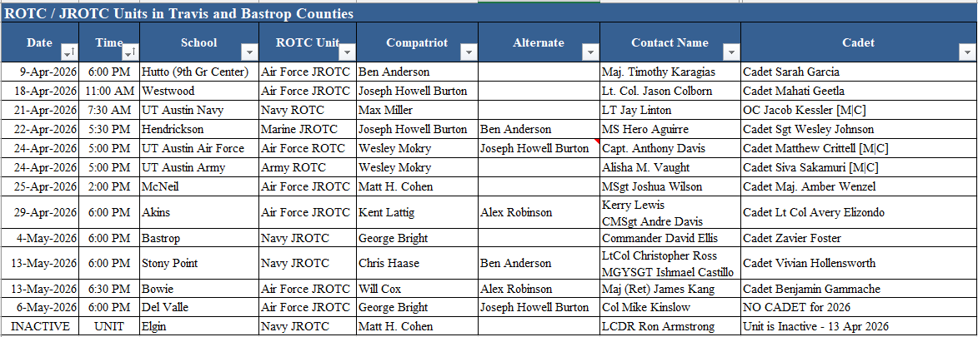
Shiidon Hawley led our Color Guard in continuing support of the many annual efforts we have supported through many presidential terms. We were especially fortunate to celebrate in our Continental Uniforms for these events in support of the Semiquincentennial. This included a new event we were invited to attend at the Camp Mabry Texas Military Forces Museum where we had the opportunity to join a musket salute at the end of the ceremony.
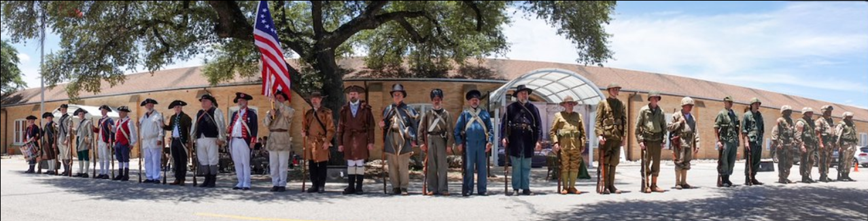
- 14 Jun - Americas 250 (Flag Day) - Old Settlers Park (4)
- 27 Jun - America 250 – Leander
- 03 Jul - Parade – Wimberly – 03 Jul (8)
- 04 Jul - Parade - Allendale (Austin) (13)
- 04 Jul - Celebration – Camp Mabry - Texas 250 Texas Military Forces Museum – (8) – Posted the Colors and Musket Salute
- 04 Jul - Parade – Fredericksburg (4)
- 04 Jul - Parade – Round Rock (4) – Alexander Hamilton
- 04 Jul – Presenting the Colors – Dell Diamond (12)
- 08 Jul - Bullock Museum Declaration of Independence Reading – Compatriot Fred Duncan and his wife selected as two of the readers (7) – Presenting the Colors

Our Chapter Color Guard and Vexillologist also participated in Partnership with the DAR Capital Area Regents in sponsoring the George Washington’s Birthday and the Constitution Day Luncheon at the Austin Woman’s Club, Chateau Bellevue, annually. In 2025, I had the honor of emceeing the George Washington Birthday Luncheon and we coordinated the Guest Speaker, Col. Brian North, Director Commanders Action Group. President Elect Mark Ellison emceed the 2026 George Washington Birthday Luncheon and coordinated the Guest Speaker, Margaret Koch, Presiding Chair -Texas America 250! Commission.
Our Chapter Registrar John Fine, who had an amazing long 8-year tenure and who brought many new Compatriots including some of the current officers into our Chapter retired at the beginning of my term and we were extremely fortunate that his Teammate Tom Fitzgerald agreed to step into the role full time. Tom has had an exceptionally busy 1st term with the 250th Anniversary increasing the profile of SAR and he has successfully completed applications through State and National for all of these new Compatriots. Two significant highlights include the Governor of Texas, Greg Abbott and his newly-appointed Secretary of State who is completing his application and should be in the Chapter by end-of-year.
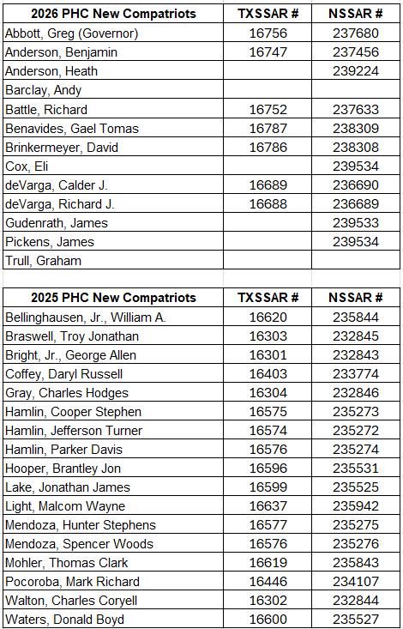
The highlight of my term in office was our Chapter’s successful hosting of the 2026 SAR Texas State Convention and SAR Cenotaph Dedication at the Texas State Cemetery. The details on these significant events in April of 2026 are included in a separate special article.
2026 SAR Texas State Convention - Special Edition

We recently caught up with Awards and Decorations for 2025 with our June Chapter Meeting where we recognised these Compatriots for their service to the Chapter.
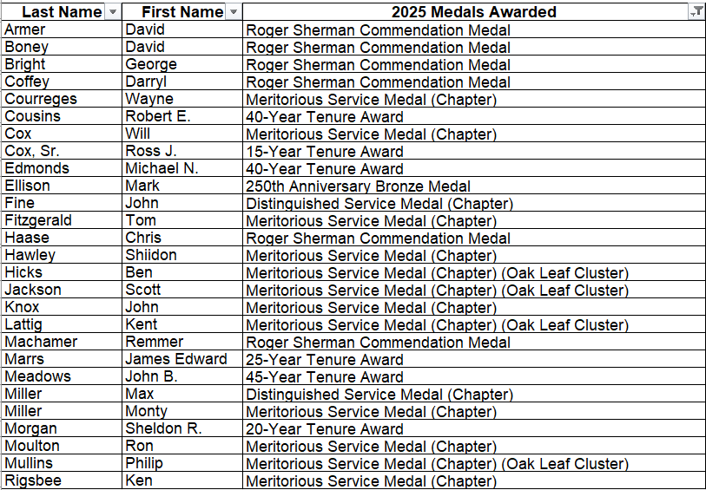
At our upcoming August Meeting, our Color Guard Commander Shiidon Hawley intends to provide 2025 Color Guard Awards and is working with State on the list.
We will complete my term in January 2026 and I have already prepared a healthy working list of those who have provided significant support to our Patrick Henry Chapter during the Semiquincentennial and will add additional names, include various Teammates who have supported us at the Texas State Cemetery through the years.
